IMPACT OF YOGA ON PHYSICAL AND MENTAL HEALTH

Submitted as Statistics project to Praxis Business School

Submitted by:

Sohan Pant-C22025

**INTRODUCTION**

**What is Yoga**

The conceptual background of yoga has its origins in ancient Indian philosophy. There are numerous modern schools or types of yoga (i.e., Iyengar, Viniyoga, Sivananda, etc.), each having its own distinct emphasis regarding the relative content of physical postures and exercises (*asanas*), breathing techniques (*pranayama*), deep relaxation, and meditation practices that cultivate awareness and ultimately more profound states of consciousness. The application of yoga as a therapeutic intervention, which began early in the twentieth century, takes advantage of the various psychophysiological benefits of the component practices. The physical exercises (*asanas*) may increase a patient's physical flexibility, coordination, and strength, while the breathing practices and meditation may calm and focus the mind to develop greater awareness and diminish anxiety , and thus result in higher quality of life. Other beneficial effects might involve a reduction of distress, blood pressure, and improvements in resilience, mood, and metabolic regulation.

**Motivation:**

During the lockdown health got a big hit, Its is when we really able to understand the pain of a unhealthy body, especially mental health. My experience during lock down left me with a rigor to managing my health by practicing yoga and meditaion.

**Objective:**

The objective of our project is to find yoga’s impact on various parameters of our body like mental health, duration of sleep, flexibility,strength,weight,BMI and to what extent it has made a change by seeing the before and after of all the parameters mentioned above.

**METHODOLOGY**

**Data source**

The data collection is done through Primary survey. To collect data we chose Morarji Desai National Institute of Yoga as our target population and we use convenience sampling (Non probability sampling) . We ask respondents 54 questions varying from personal detail to mental health questions.

**Pre-processing of data**

To further proceed with the project, cleaning of the data is very important. While collecting data

We tried to make it simple for the respondents. As our questionnaire was lengthy we have to trade off between relevance of data over cleanliness of the data.

Some instances are

A- we collected data of height in random parameters and while cleaning the data we made all the different parameters as one.

B- We collected data on two time intervals i.e before joining the course and after joining the course.

C- We collected data from multiple questions of each rating from 1 to 10, then we made an index by clubbing them all together.

D-Clubbing and indexing we did on many parts of our data, like Routine, Physical health, Mental health etc.

**Distribution of responses**

Data is collected from 48 respondents of the Morarji Desai National Institute of Yoga. Respondents are from different courses provided by the Institute. These respondents are distributed via course, age , sex to analyse the data more accurately.

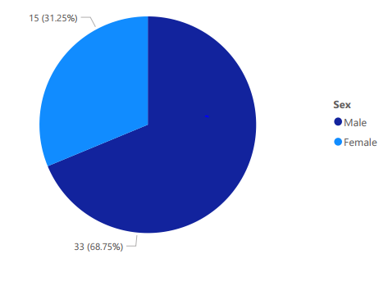

This above pie chart shows us that what is the sex ratio of the respondents,thirty three(68.75%) of our respondents are male whereas fifteen(31.25%) of our respondents are female.

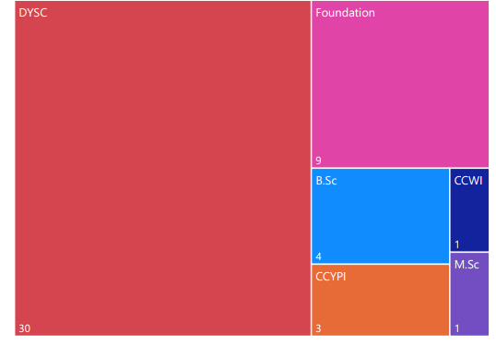

The above tree map chart shows the count of respondents according to the course they are pursuing. Most of the respondents are from the DYSC( 1 year diploma course) and followed by foundation level course ( 50 hours course).

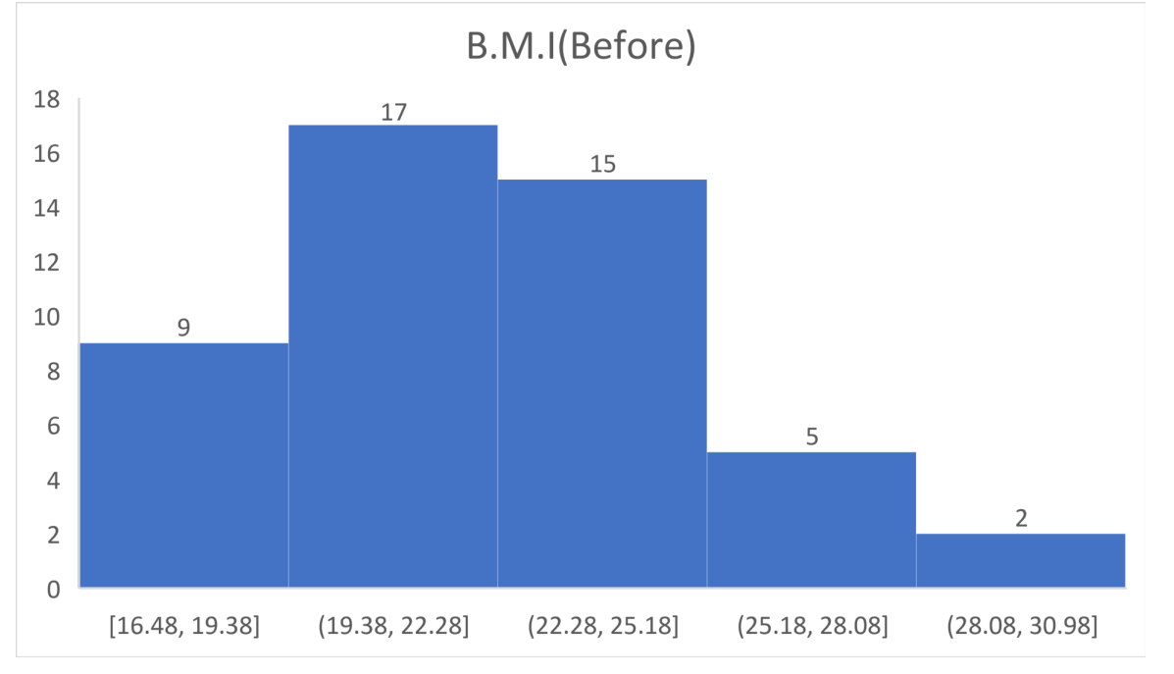

We collected data of weight and height of the respondents to calculate their B.M.I so we can quantify the change in B.M.I due to yoga practices.

**Distribution of Age**

Like the above parameters, age can also be used to analyze the scatterness of the data . Below table is showing the summary statistics of age of respondents. The average age of the respondents is 23.64 , middle age is 22 and mode is also 22.

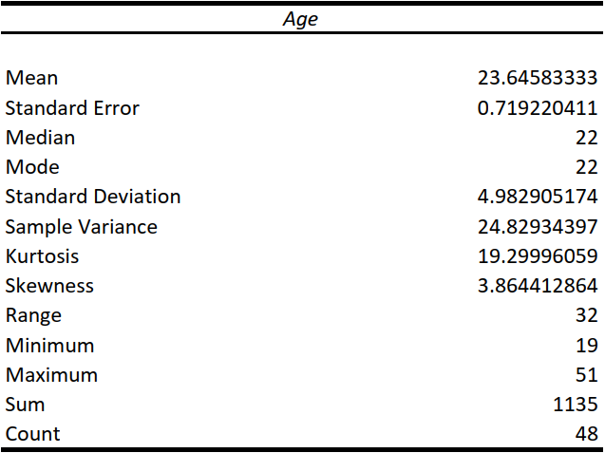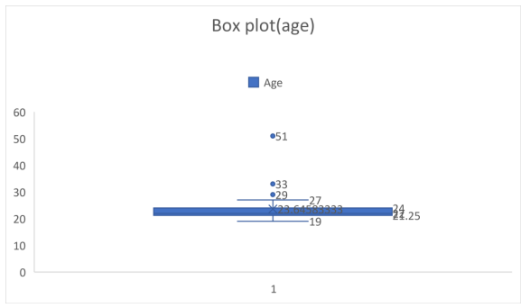

A box and whisker plot—also called a box plot—displays the five-number summary of a set of data. The five-number summary is the minimum = **19** , first quartile=**21.25**, median=**22**, third quartile=**24**, and maximum=**27**. In a box plot, we draw a box from the first quartile to the third quartile. A horizontal line goes through the box at the median. Below and above the whisker lies outliers, in this case outliers are lying above maximum value. Outliers are aged **29,33, and 51**.

The below box plot shows the various distributions of age of respondents . This graph is right skewed histogram, which signifies that the stratch lies on the right side.

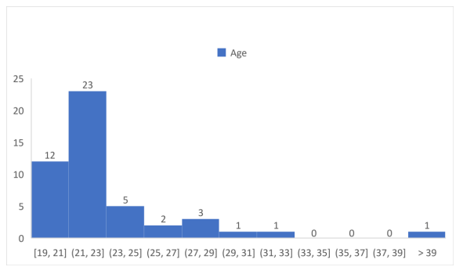

**Practice Routine**

The practice routine at Morarji Desai National Institute of Yoga is the same for all the respondents. MDNIY’s practice routine is 2 hours daily and 5 days a week. We ask respondents to rate their practice routine on two parameters i.e toughness and effectiveness of the routine and then clubbed them to come at a weighted practice routine score. Below pie charts showing their average practice routine ratings by three categories come out of weight change.

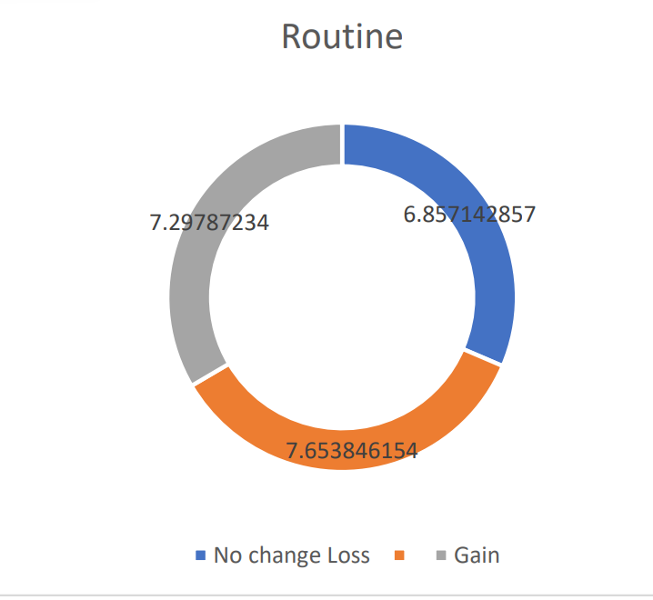

**IMPACT ON SLEEP**

Practicing yoga regularly can help you to manage your sleep better. You may be able to fall asleep quicker, sleep for longer, and go back to sleep even after waking up at night. We asked respondents about their sleep routine and how much change is there in their sleep quality they observed before and at present.

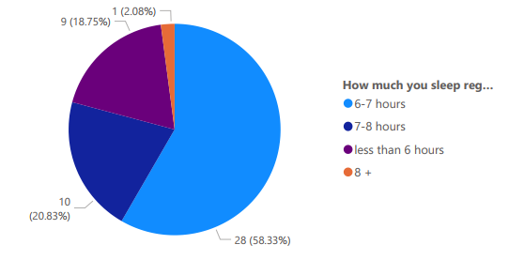

Insights from the above graph is twenty eight(58.33%) of our respondents are sleeping six to seven hours regularly,ten(20.83%) of them are sleeping seven to eight hours a day,nine(18.75%) of them are sleeping less than six hours a day and one(2.08%) of them is sleeping more than eight hours a day.

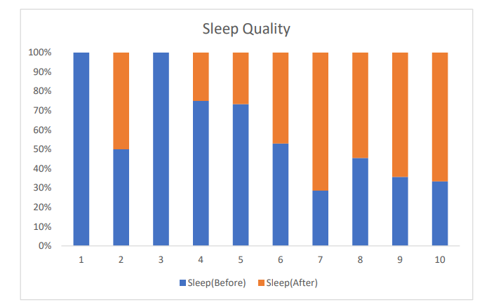

The above stacked bar graph shows the improvement in sleep quality as per respondents' responses.

We find out that before the course Blue bars are bigger at lower ratings, while at present the ratings are mainly on the higher side. Which clearly shows that the sleep quality of the Respondents are increasing with continuous yoga practice.

**IMPACT ON PHYSICAL HEALTH**

Yoga is an art of eradicating all the fluctuations of the mind, though nowadays we mostly describe slow movements and deep breathing exercises. Slow movements and deep breathing increase blood flow and warm up muscles, while holding a pose can build strength and improve your posture

Yoga is as good as basic stretching for easing pain and improving mobility in people with lower back pain. Practicing yoga and pranayam on a regular basis increases the overall energy level of the practitioner. One may feel increased mental and physical energy, a boost in alertness and enthusiasm, and fewer negative feelings after getting into a routine of practicing yoga.

We collected these questions , Strength, Stamina , Flexibility, Posture and overall energy level and We clubbed these questions in one and made an index to measure the change in the overall physical aspect of the respondents . The index measure of physical health is 50.

**HOW WE ARE INTERPRETING THE RESULT**

We have put the changes in weight of respondent’s data into three categories as follows:

When we calculate the weight difference then we come across three categories which are ‘No change’, ‘Weight Gain’ , ‘Weight loss’.

Category 1:No change

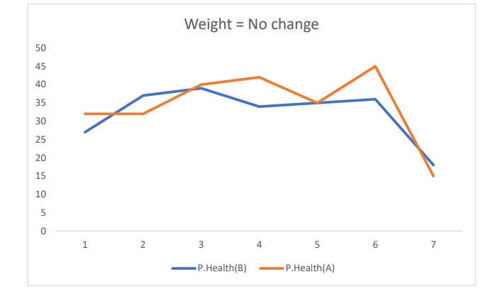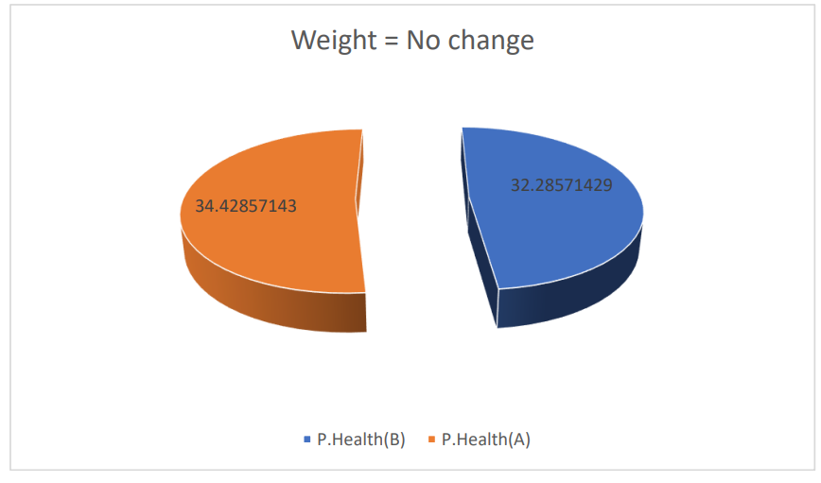

These above graphs show the change in physical health for the category 1 responders. As we can see there is not much change in the physical health of the respondents. The line graph shows change of individual respondents and the pie chart is showing average change in the category 1 respondents .

Category 2: Weight Gain

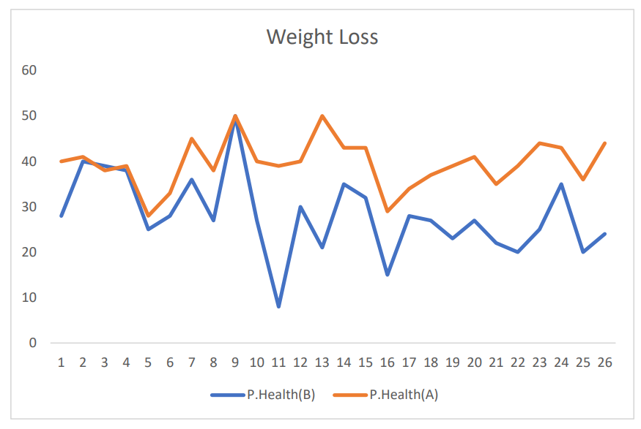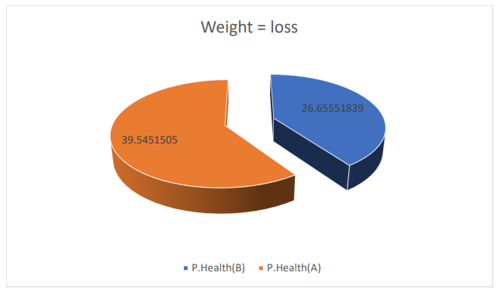

This category contains all the respondents who have gained weight after practicing yoga.The line graph showing change of individual respondents and the pie chart is showing average change in the category 2 respondents . as we can see the gap between the lines of the category is greater than the ‘no change’ category. There is a good correlation between change in weight and improvement in physical health of the respondents.

Category 3:Weight loss

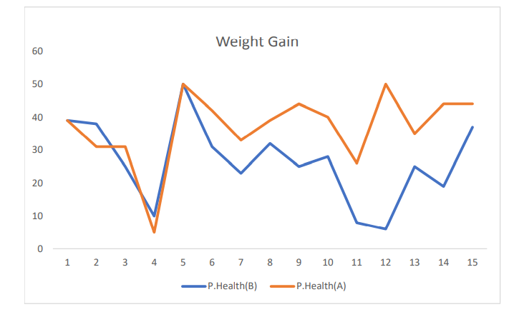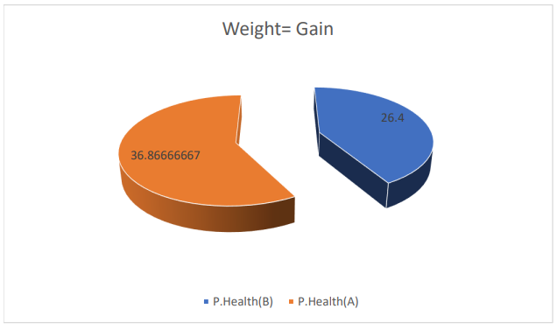

This category contains all the respondents who have lost weight after practicing yoga.The line graph showing change of individual respondents and the pie chart is showing average change in the category 3 respondents . as we can see the gap between the lines of the category is greater than ‘no change’ and category 2. It is a good correlation between change in weight and improvement in physical health of the respondents.

**IMPACT ON MENTAL HEALTH**

Category 1= No change

This category contains all the respondents whose weight do not change after practicing yoga.The bar graph showing change of individual respondents and the pie chart is showing average change in the category 3 respondents . As we can see the difference between the bars is not very significant. It is a good correlation between no change in weight and nearly no change in the mental health of the respondent.

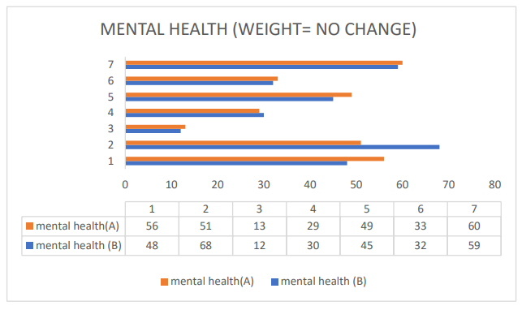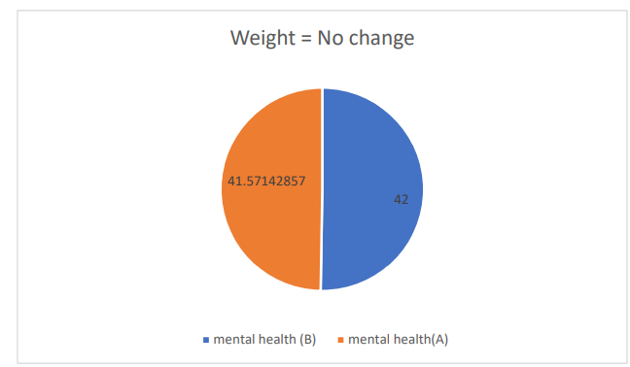

*Scale for the mental health index is 80. And a lower score means improvement in mental health.

**Category 2 = Weight loss**

This category contains all the respondents who have lost weight after practicing yoga.The bar and area graph showing change of individual respondents and the pie chart showing average change in the category 2 respondents . As we can see the area charts showing the mental health score before joining the course and the bar graph showing at present , we can see the score of mental health index at present is lower which is a good sign that the practice of yoga reduced mental problems.

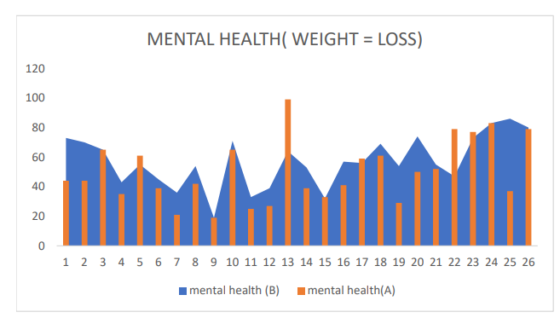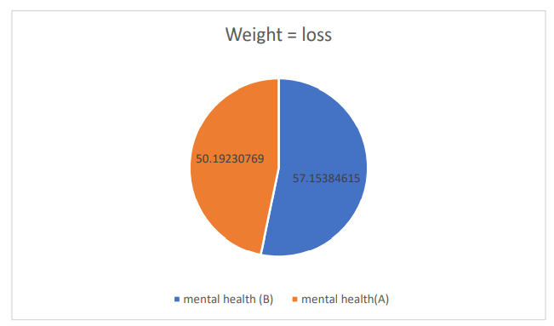

*Scale for the mental health index is 80. And a lower score means improvement in mental health.

**Category 3 = Weight Gain**

This category contains all the respondents who have gained weight after practicing the yoga. To show the change for individuals we are using radar to show the change in mental health . as the orange lines are shrinking which is a sign that the mental health index is reducing and mental health is improving. The bar graph showing the average improvement on the mental health index of the respondents

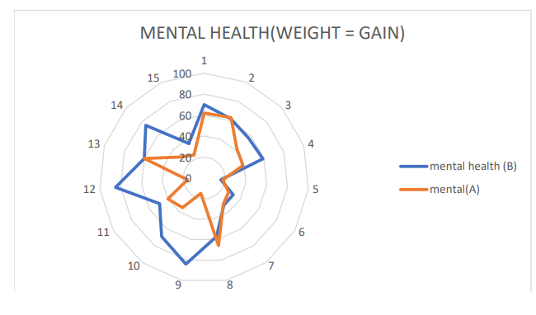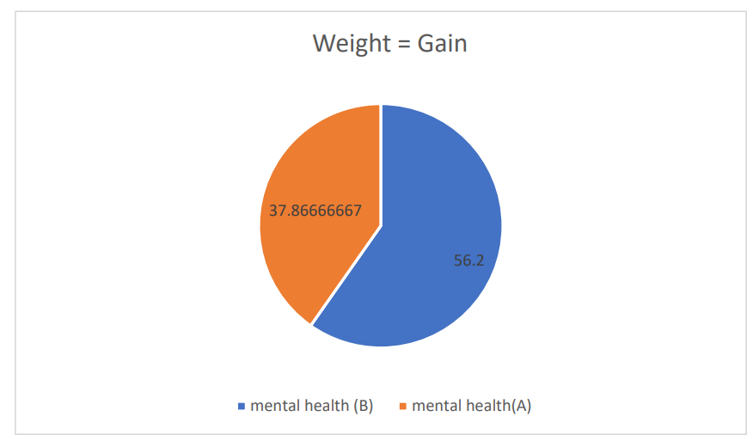

*Scale for the mental health index is 80. And a lower score means improvement in mental health.

**Conclusion**

After analyzing the data we can conclude that after practicing yoga one's mental and physical health improves. As we saw those respondents who have seen no change in their weight also don’t put much effort and even don’t improve much on mental and physical health index. Those who gained and lost significantly showed more dedication and more improvement on their mental and physical health.

**Reference**

1-We have collected our data from the students of Morarji Institute of Technology. We had shared a google form which had fifty four questions related to the various parameters of mental and physical health.

2-We took help from Nikita Nailwal(DYSC student) for domain knowledge .